**Academic Year: 2023-24 Semester: V Class / Branch: TE IT**

**Subject: DevOPs Lab (DL)**

**Subject Lab In-charge: Prof. Sonal Jain/Prof. Neha Deshmukh**

**EXPERIMENT NO. 08**

**Aim: To demonstrate container lifecycle using various docker commands.**

**Theory:**

Docker is a platform that allows us to package our applications into deployable executables called containers, with all its necessary OS libraries and dependencies.

A container is a process in OS. A process is an instance of a computer program that is being executed. But container processes are different. Container processes are fully-functional environments, and they have more isolation from the OS than the processes in OS.Just like processes, containers have different states throughout their lifecycle.

There are mainly five states that a container can be in during its lifecycle -

* Created state
* Running state
* Paused state/ Unpaused state
* Stopped state
* Killed/Deleted state

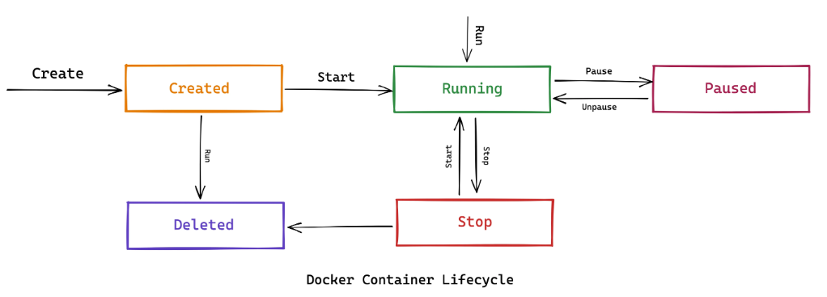

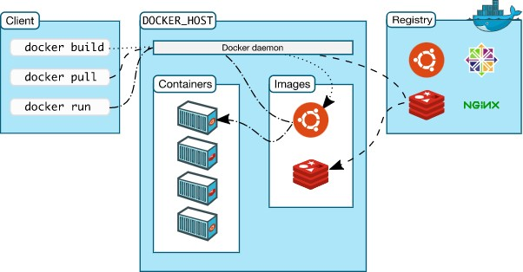

**Fig. Architectural overview of Kubernetes**

**Docker Commands:**

Following command is used to get the currently installed version of docker

sudo apt-get install docker

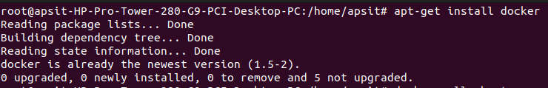

1. **docker –version: To check the installed version of docker**

docker --version

1. **docker pull:**

Following command is used to pull images from the docker repository(hub.docker.com)

Usage: docker pull <image name>

docker pull ubuntu

docker pull mysql

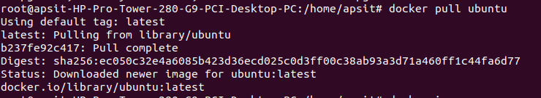

1. **docker images: This command is used to show all the pulled images from docker**

**docker images**



1. docker run: This command is used to access the running container

Usage: docker run -it -d <image name>

docker run -it -d ubuntu



1. **docker ps : This** command lists the running containers

**docker ps**

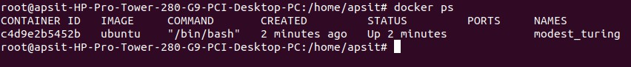

1. **docker ps -a**: **This** command lists all the running containers

docker ps -a

1. **docker exec: This command is used executes the container.**

Usage: docker exec -it <container id> bash



1. ls: This command lists the directories available under Ubuntu Image

ls

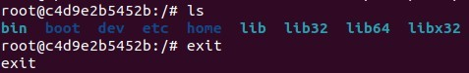

1. **docker stop**

Usage: docker stop <container id>

1. **docker kill**

Usage: docker kill <container id>

1. **docker rm**

Usage: docker rm <container id>

1. **docker rmi**

Usage: docker rmi <image-id>

Task 2: To pull the image of mysql from docker hub

Step 1:

docker pull mysql

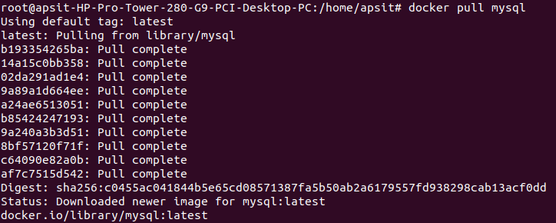

Step 2:

docker run –name –sumit -e MYSQL_USER=user -e MYSQL_PASSWORD=root -e MYSQL_DATABASE=apple -e MYSQL_ROOT_PASSWORD=root -d mysql

Step 3:

docker ps



Step 4:

docker exec -it <container id> bash

Step 5: Login to mysql server

bash-4.4# mysql -u root -p

mysql> show databases;

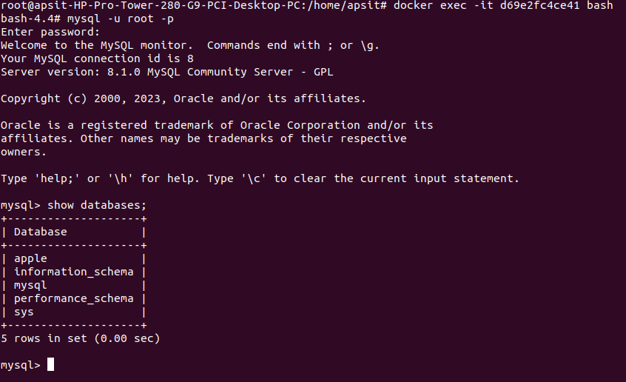

**Conclusion:** In this experiments student have learnt how to deal with containerization technology to pull, run, remove, and execute the containerized environment using various docker commands.